**Software Testing Assignment**

**Advanced Selenium**

# Assignments Module – 5 (Selenium IDE)

* What is Automation Testing?

1. Automation testing is the use of software to control the execution of tests, the comparison of actual outcomes to predicted outcomes, the setting up of test preconditions, and other test control and test reporting functions.

* Which Are The Browsers Supported By Selenium Ide?

1. The Browsers Supported By Selenium Ide are Mozilla Firefox, Google Chrome, Microsoft Edge, Safari, and Opera.

* What are the benefits of Automation Testing?

1. Scripts runs fast. Tests perform precisely same operations each time they are run. Can be tested how the application reacts after repeated execution of the same operation. Can build a suite of tests that covers every feature in our application.We can reuse tests on different versions of an application, even if the user interface changes.

* What are the advantages of Selenium?

1. Very easy to use and install. No programming experience is required, though knowledge of HTML and DOM areneeded. Provides support for extensions. Has built-in help and test results reporting module. Can export tests to formats usable in Selenium RC and WebDriver.

* Why testers should opt for Selenium and not QTP?

A)

|  |  |
| --- | --- |
| Selenium | QTP |
| * Open source, free to use, and free of charge. | * Commercial |
| * Highly extensible. | * Limited addons |
| * Can run test across different browsers. | * Can only run tests in Firefox, Internet Explorer and Chrome. |
| * Supports various operating systems. | * Can only be used in windows. |
| * Can execute tests in parallel | * Can only execute in parallel but using Quality Center which is again a paid product. |

* To validate the Swaglab website Login and logout process page https://www.saucedemo.com

# Assignments Module – 6 (Core Java)

* W.A.J.P to Take three numbers from the user and print the greatest number.
* W.A.J.P in Java to display the first 10 natural numbers using while loop.
* W.A.J.P to find factorial for Given Number.
* W.A.J.P to check given number is Prime or not?
* W.A.J.P to check given number is Armstrong or not?
* W.A.J.P for create Fibonacci Series.
* W.A.J.P to Print pattern Given Below.

1)

1

12

123

1234

12345

2)

1

12

123

1234

12345

3)

1

01

101

01010

101010

4)

1

1. 2
2. 3 3
3. 4 4 4

5)

*

* + * *
  + * * * *
  + * *

*

* WAP to compute the sum of the first 100 prime numbers.
* WAP to sum values of an array.
* WAP to calculate the average value of array elements.

* WAP to find the index of an array element.
* WAP to find the maximum and minimum value of an array.
* WAP to Compare Two String.
* WAP to concatenate a given string to the end of another string.
* WAP to demonstrate try catch block.
* WAP to demonstrate multiple catch blocks
* WAP to create one thread by implementing Runnable interface in Class.
* WAP to create one thread by extending Thread class in another

Class.

* WAP to iterate through all elements in an array list.
* WAP to update specific array element by given element.
* WAP to remove the third element from a array list. • WAP to Copy one array into another
* WAP to reverse an array of integer values.
* WAP to find the second largest element in an array.
* W.A.J.P. Create an abstract class 'Parent' with a method 'message'. It has two subclasses each having a method with the same name 'message' that prints "This is first subclass" and "This is second subclass" respectively.

Call the methods 'message' by creating an object for each subclass.

* W.A.J.P. which will ask the user to enter his/her marks (out of 100). Define a method that will display grades according to the marks entered as below:

|  |  |
| --- | --- |
| Marks | Grade |
| 91-100 | AA |
| 81-90 | AB |
| 71-80 | BB |
| 61-70 | BC |
| 51-60 | CD |
| 41-50 | DD |
| <=40 | Fail |

* W.A.J.P. to create a custom exception if Customer withdraw amount which is greater than account balance then program will show custom exception otherwise amount will deduct from account balance.

Account balance is:2000 Enter withdraw amount:2500

Sorry, insufficient balance, you need more 500 Rs. To perform this transaction.

# Module – 7 (Selenium Webdriver)

**Demo Websites To Practice selenium Webdriver**

|  |  |
| --- | --- |
|  | **Website**  **List** |
| • | [1 List of Websites to Practice Selenium](https://www.techbeamers.com/websites-to-practice-selenium-webdriver-online/#list-ofwebsites-to-practice-selenium)    o 1.1 1. https://phptravels.com/demo/ o [1.2 2. http://thedemosite.co.uk/](https://www.techbeamers.com/websites-to-practice-selenium-webdriver-online/#2httpthedemositecouk) o [1.3 3. http://newtours.demoaut.com/](https://www.techbeamers.com/websites-to-practice-selenium-webdriver-online/#3httpnewtoursdemoautcom) o [1.4 4. http://the-internet.herokuapp.com/](https://www.techbeamers.com/websites-to-practice-selenium-webdriver-online/#4httpthe-internetherokuappcom) o [1.5 5. http://automationpractice.com/index.php](https://www.techbeamers.com/websites-to-practice-selenium-webdriver-online/#5httpautomationpracticecomindexphp) o [1.6 6. http://book.theautomatedtester.co.uk/](https://www.techbeamers.com/websites-to-practice-selenium-webdriver-online/#6httpbooktheautomatedtestercouk) o [1.7 7. https://s1.demo.opensourcecms.com/wordpress/](https://www.techbeamers.com/websites-to-practice-selenium-webdriver-online/#7httpss1demoopensourcecmscomwordpress) |

* W.A.J.Script for Locating links by linkText() and partialLinkText()

* W.A.J.Script for Selecting multiple items in a drop dropdown
* W.A.J. script to use different methods to manage the windows-alerts and pop ups.
* W.A.J.script to register your self in Gmail.
* W.A.J. Script To perform the radio button to select one by one in loop <http://demo.guru99.com/test/radio.html>

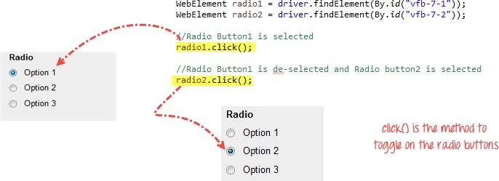

* W.A.J. script To write the script for image of logo facebook using xpath.

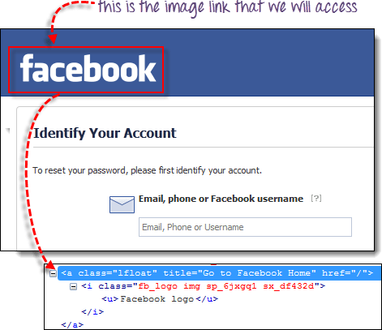

* W.A.J.Script To write a script for drop down.

<http://demo.guru99.com/test/newtours/register.php>

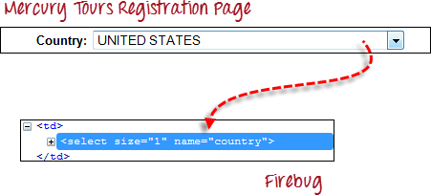

* W.A.J.Script To use Mouse and Keyboard event using Action class 1.Mouse Hover Event

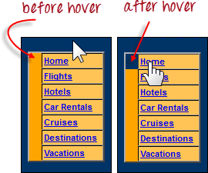

2. Keyboard event

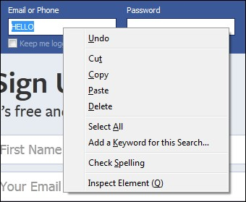

* W.A.J. Script How to handled Alert in selenium

["http://demo.guru99.com/test/delete_customer.php "](http://demo.guru99.com/test/delete_customer.php)

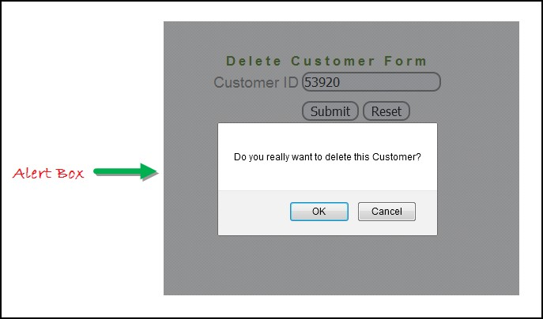

* W.A.J. Script To find the total hyperlink from this web page <http://demo.guru99.com/test/web-table-element.php>

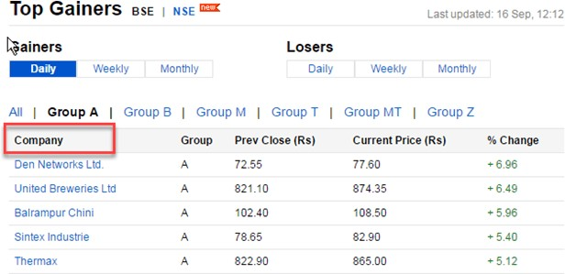

* W.a.junit program to handled Assert class with all method to check its pass or fail
* W.a. junit program to perform test with webdriver to login process of facebook
* W.a. junit program to check gmail login using with

@before,@after,@Test

* W.a. junit program to use parameterized demo with multiple parameter of Facebook login in junit.
* W.a. TestNG program to perform test with webdriver to login process of facebook
* W.a. TestNG program to check gmail login using with

@beforetest,@aftertest,@Test

* W.a. TestNG program to use parameterized demo with multiple parameter of Facebook login with TestNG.
* W.a. TestNG program to create group with testing.xml file • w.a. TestNG program to create dataprovider.

# Module – 8 (Automation Testing Framework)

* W.a.framework program for data driven framework

-to get value from the excel and check into your website

[(http://automationpractice.com/index.php?controller=authentication&b ack=myaccount)](http://automationpractice.com/index.php?controller=authentication&back=my-account) Direct check with login which emaild through login successful or not)

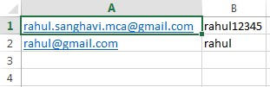

* W.a.framework program for keyword driven framework

-given below keyword which you get from the Excel and check into you website [(http://automationpractice.com/index.php)](http://automationpractice.com/index.php)

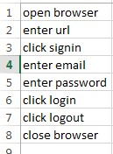

* W.a.framework program for hybrid driven framework

-given below keyword and Data both which you get from the Excel and check into you website [(http://automationpractice.com/index.php)](http://automationpractice.com/index.php)

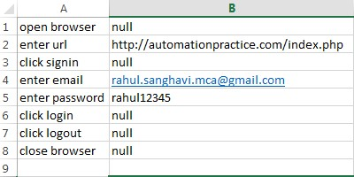

* W.a.maven program to create simple webdriver Program
* **W.a.maven program to create Junit with webdriver Program**
* W.a.maven program to create TestNG with Webdriver Program.

## Module – 9 (APPIUM Testing)

1. Write an Appium Program to connect with emulator and open APIdemo.app application on your emulator
2. Write an Appium Program to connect with Realdevice and open APIdemo.app application on your realdevice.
3. Write an Appium Program to connect with emulator wit ecommerce based application using Generalstore.app to perform locators like name, dropdown etc.
4. Write an Appium Program to connect with emulator wit ecommerce based application using Generalstore.app to perform swipe demo to swipe the menu.
5. Write an Appium Program to connect with realdevice using APIDemo.app to perform longpress to open to side menu.
6. Write an Appium Program to connect with realdevice using APIDemo.app to perform scrolling the all option.
7. Write an Appium Program to connect with realdevice using APIDemo.app to open the calculator and calculate all the operation like (addition, substraction, multiplication, division).

## Module – 10 (API Testing)

Api testing link : <https://restapilive.onrender.com/>

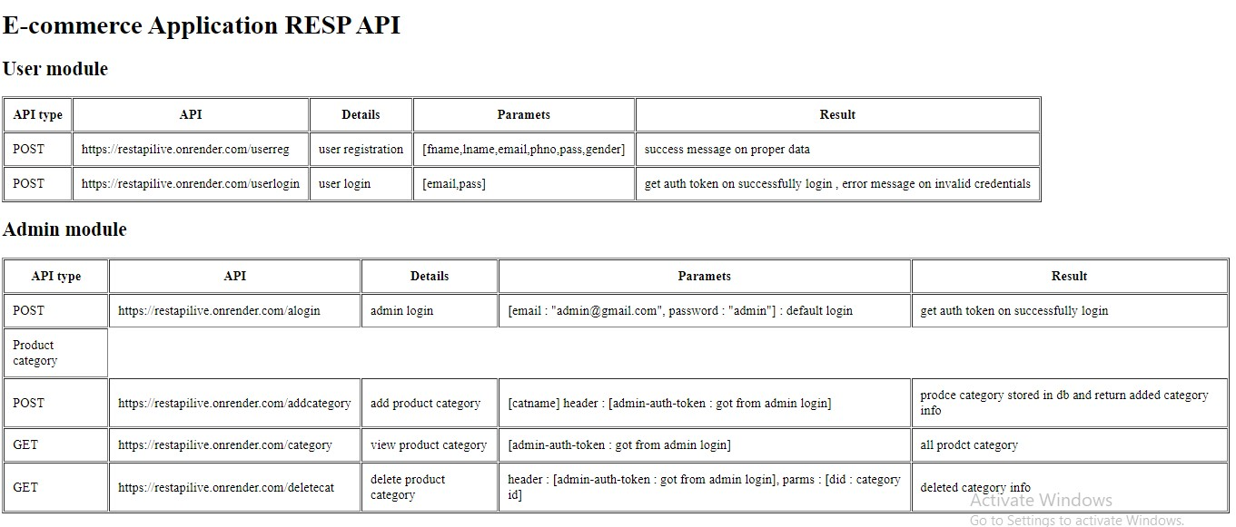

1. to test in above API which is passed in parameter as a column in user module to check the registration performed or not and get the result is coming or not (Method=POST)
2. to test in above API which is performed login wit using parameter in user module and check generate token or not (Method=POST)
3. to test in above API which is performed login wit using parameter in admin module and check generate token or not (Method=POST)
4. to test in above API which is performed login wit using parameter in admin module and check generate token header : [admin-auth-token : got from admin login] and add category with the help of token (Method= POST)
5. to test in above API which is performed login wit using parameter in admin module and check generate token [admin-auth-token : got from admin login] to display all the category (Method=GET)
6. to test in above API which is performed login wit using parameter in admin module and check generate token[admin-auth-token : got from admin login] to delete the category (Method=GET)